**Overview**

This report provides a summary of employee attrition data for the given period. Key metrics include:

* **Employee Count:** Total number of employees.
* **Active Employee:** Number of employees currently employed.
* **Attrition Count:** Number of employees who have left the organization.
* **Attrition Rate:** Percentage of employees who have left the organization.
* **Avg Age:** Average age of employees.

**Key Findings**

* **Total Employee Count:** As of [Date], there are 1,473 employees.
* **Active Employee:** Currently, 1,236 employees are actively working.
* **Attrition:** A total of 237 employees have left the organization during the specified period.
* **Attrition Rate:** The attrition rate stands at 16.09%, indicating that approximately 16.09% of the workforce has left the company.
* **Average Age:** The average age of employees is 37.

**Attrition by Age Group**

The provided pie charts illustrate the distribution of employee attrition across different age groups. Key observations include:

* **18-25:** A relatively high proportion of employees in this age group have experienced attrition.
* **26-35:** Attrition rates are moderate within this age range.
* **36-45:** The attrition rate appears to be lower compared to the younger age groups.
* **46-55:** Attrition levels are relatively low in this group.
* **55+:** The oldest age group shows the lowest attrition rate.

**Department-Wise Attrition**

The pie chart on the right provides a breakdown of attrition by department:

* **Research & Development:** This department exhibits the highest attrition rate, indicating a significant number of departures.
* **Sales:** The attrition rate in the Sales department is moderate.
* **Human Resources:** The Human Resources department has the lowest attrition rate among the three.

**Attrition by Gender**

The bar chart illustrates the distribution of attrition by gender:

* **Female:** A lower number of female employees have left the organization compared to male employees.
* **Male:** A higher number of male employees have experienced attrition.

**Attrition by Travel**

The bar chart on the right shows the relationship between travel frequency and attrition:

* **0-10 Trips:** Employees with a lower travel frequency (0-10 trips) have a relatively low attrition rate.
* **11-20 Trips:** Attrition rates increase slightly for employees who travel 11-20 times.
* **21-30 Trips:** The highest attrition rate is observed among employees who travel 21-30 times.

**Attrition by Salary Slab**

The provided bar chart illustrates the distribution of attrition across different salary slabs:

* **Up to 5k:** Employees in the lowest salary slab (up to 5k) have the highest attrition rate.
* **5k-10k:** Attrition rates are moderate in this salary range.
* **10k-15k:** A slightly lower attrition rate is observed in the 10k-15k salary slab.
* **15k+:** The highest salary slab exhibits the lowest attrition rate.

**Attrition by Years at Company**

The provided line chart illustrates the relationship between tenure (years at the company) and attrition:

* **0-5 Years:** A relatively high number of employees leave within the first five years of employment.
* **6-10 Years:** Attrition rates remain moderately high in this tenure range.
* **11-15 Years:** A slight decrease in attrition is observed.
* **16-20 Years:** Attrition rates stabilize at a relatively low level.
* **21+ Years:** Employees with 21 or more years of tenure have a minimal attrition rate.

**Job Satisfaction Rating**

The provided table and heatmap offer insights into job satisfaction ratings across different job roles:

* **Highest Satisfaction:** The Research Scientist role exhibits the highest overall job satisfaction, with an average rating of 95 out of 100.
* **Lowest Satisfaction:** The Human Resources role has the lowest overall job satisfaction, with an average rating of 13 out of 100.
* **Key Trends:** Some roles, such as Sales Executive and Laboratory Technician, show high levels of job satisfaction, while others, like Manager and Research Director, have more mixed ratings.

**Department Environment Satisfaction**

The pie chart provides a breakdown of department environment satisfaction:

* **Research & Development:** This department demonstrates the highest level of satisfaction with the work environment.
* **Sales:** The Sales department has a moderate level of environment satisfaction.
* **Human Resources:** The Human Resources department exhibits the lowest satisfaction with the work environment.

**Age and Training Times**

The line chart illustrates the relationship between age and training times over the past year:

* **General Trend:** There appears to be a general trend of decreasing training times with increasing age.
* **Specific Age Groups:** The 18-25 age group receives the highest number of training hours, while the 55+ age group receives the least.

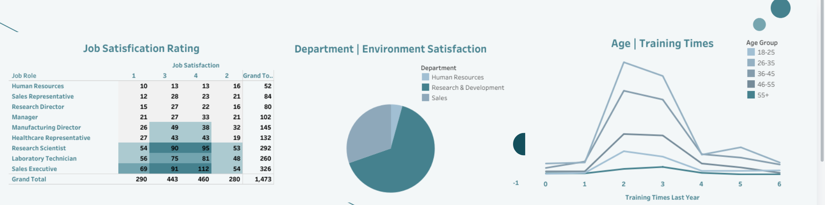

**Analysis of Environment Satisfaction by Job Role and Gender/Department**

**Environment Satisfaction by Job Role**

The provided bar chart illustrates the distribution of environment satisfaction ratings across different job roles:

* **Highest Satisfaction:** The Sales Executive role demonstrates the highest level of satisfaction with the work environment.
* **Lowest Satisfaction:** The Human Resources role exhibits the lowest satisfaction with the environment.
* **Key Trends:** Some roles, such as Research Scientist and Laboratory Technician, show moderate levels of satisfaction, while others, like Manager and Sales Representative, have lower ratings.

**Gender/Department**

The bar chart on the right provides a breakdown of employee count by gender and department:

* **Female:** The Sales department has the highest number of female employees, followed by Research & Development.
* **Male:** The Research & Development department has the highest number of male employees, followed by Sales.
* **Overall:** The Research & Development department has the largest overall employee count, with a relatively balanced gender distribution.

